Installation Guide – Teamcenter 13

Status: 06/2020



EPLAN Software & Service GmbH & Co. KG  
Technical information

Copyright © 2014 EPLAN Software & Service GmbH & Co. KG

EPLAN Software & Service GmbH & Co. KG assumes no liability for either technical or printing errors, or for deficiencies in this technical information and cannot be held liable for damages that may result directly or indirectly from the delivery, performance, and use of this material.

This document contains legally protected proprietary information that is subject to copyright. All rights are protected. This document or parts of this document may not be copied or reproduced by any other means without the prior consent of EPLAN Software & Service GmbH & Co. KG.

The software described in this document is subject to a license agreement. The use and reproduction of the software is only permitted within the framework of this agreement.

RITTAL® is a registered trademark of Rittal GmbH & Co. KG.

EPLAN®, EPLAN Electric P8®, EPLAN Fluid®, EPLAN PPE®, EPLAN Cabinet®, EPLAN Pro Panel®, EPLAN Mechatronic Integration® and EPLAN Harness proD® are registered trademarks of EPLAN Software & Service GmbH & Co. KG.

Windows 7®, Windows 8®, Windows Server 2012®, Microsoft Windows®, Microsoft® Excel®,   
Microsoft® Access® and Notepad® are registered trademarks of the Microsoft Corporation.

PC WORX®, CLIP PROJECT®, and INTERBUS® are registered trademarks of Phoenix Contact GmbH & Co.

AutoCAD® and AutoCAD Inventor® are registered trademarks of Autodesk, Inc.

STEP 7®, SIMATIC® and SIMATIC HW Konfig.® are registered trademarks of Siemens AG.

InstallShield® is a registered trademark of InstallShield, Inc.

Adobe® Reader® and Adobe® Acrobat® are registered trademarks of Adobe Systems Inc.

TwinCAT® is a registered trademark of Beckhoff Automation GmbH.

Unity Pro® is a registered trademark of Schneider Electric.

RSLogix 5000® and RSLogix Architect® are registered trademarks of Rockwell Automation.

All other product and trade names and company names are trademarks or registered trademarks of their respective owners.

EPLAN uses the Open Source software 7-Zip (7za.dll), Copyright © by Igor Pavlov. The source code of 7-Zip is subject to the GNU Lesser General Public License (LGPL). The source code of 7-Zip as well as details on this license are available on the following Internet page: http://www.7-zip.org

EPLAN uses the Open-Source-Software Open CASCADE, Copyright © by Open CASCADE S.A.S. The source code of Open CASCADE are subject to the Open CASCADE Technology Public License. For the Open CASCADE source code and more details about this license, go to: http://www.opencascade.org

Table of contents

[Table of contents 4](#_Toc44311516)

[System environment 6](#_Toc44311517)

[Database / operating system 6](#_Toc44311518)

[Additional Software 6](#_Toc44311519)

[Installation Database SQL Server 2017 Express Advanced Edition 7](#_Toc44311520)

[Install database 7](#_Toc44311521)

[Server Configuration 10](#_Toc44311522)

[Installation SQL Server Management Studion 13](#_Toc44311523)

[Activate database protocols 14](#_Toc44311524)

[Installation JAVA 15](#_Toc44311525)

[Installation JDK 1.8.0\_191 (64bit) 15](#_Toc44311526)

[Set preconditions for PLM license server 16](#_Toc44311527)

[Modify hosts file 16](#_Toc44311528)

[Installation Teamcenter 17](#_Toc44311529)

[Create a Teamcenter database inside MS-SQL 17](#_Toc44311530)

[Edit script create database for MS-SQL database 17](#_Toc44311531)

[Run database creation script 19](#_Toc44311532)

[Installation Teamcenter server incl. 2-tier client 21](#_Toc44311533)

[Installation 4-Tier Client 41](#_Toc44311534)

[Installation Thin-Client 49](#_Toc44311535)

[Copy the ICDs of Tc13 49](#_Toc44311536)

[Add the web\_tier 51](#_Toc44311537)

[Disk Locations for Install Images: 52](#_Toc44311538)

[Solutions 52](#_Toc44311539)

[Modify Required Context Parameters 53](#_Toc44311540)

[Installation and configuration Apache Web Application Server 55](#_Toc44311541)

[Installation Tomcats 55](#_Toc44311542)

[Deploy of web\_tiers 55](#_Toc44311543)

[Set system variables 56](#_Toc44311544)

[Setup 57](#_Toc44311545)

[Automatic Service 58](#_Toc44311546)

System environment

Database / operating system

• Operating system: Windows Server 2016

Additional Software

• Teamcenter 13

• MS-SQL 2017

• JBOSS (5.1.0.GA-jdk6)

Additionally necessary SQL database licenses are required.

# Installation Database SQL Server 2017 Express Advanced Edition

## Install database

*Run file as administrator*

"C:\Inst\SQLEXPRADV\_x64\_ENU\SETUP.EXE"  
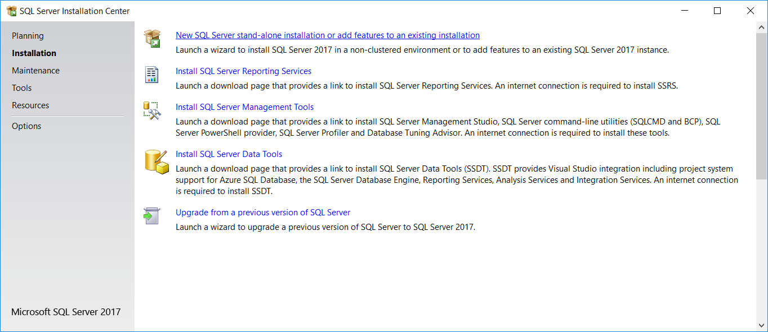

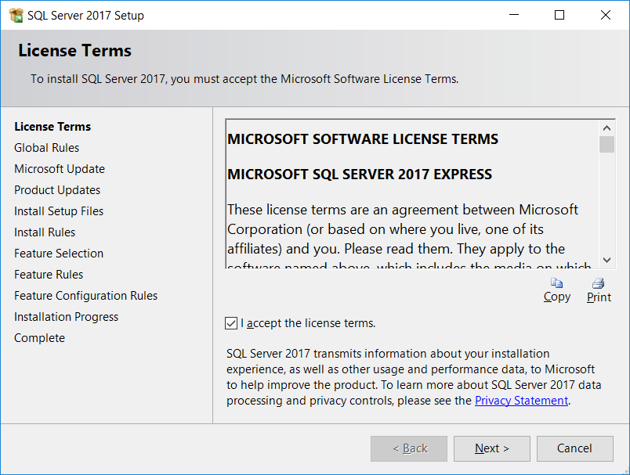

Next 🡪

Ignore warning 🡪 Next  
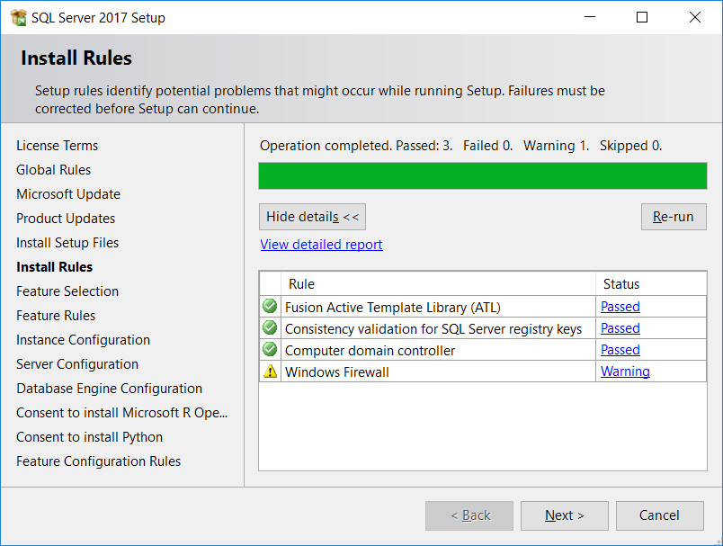

***Feature Selection***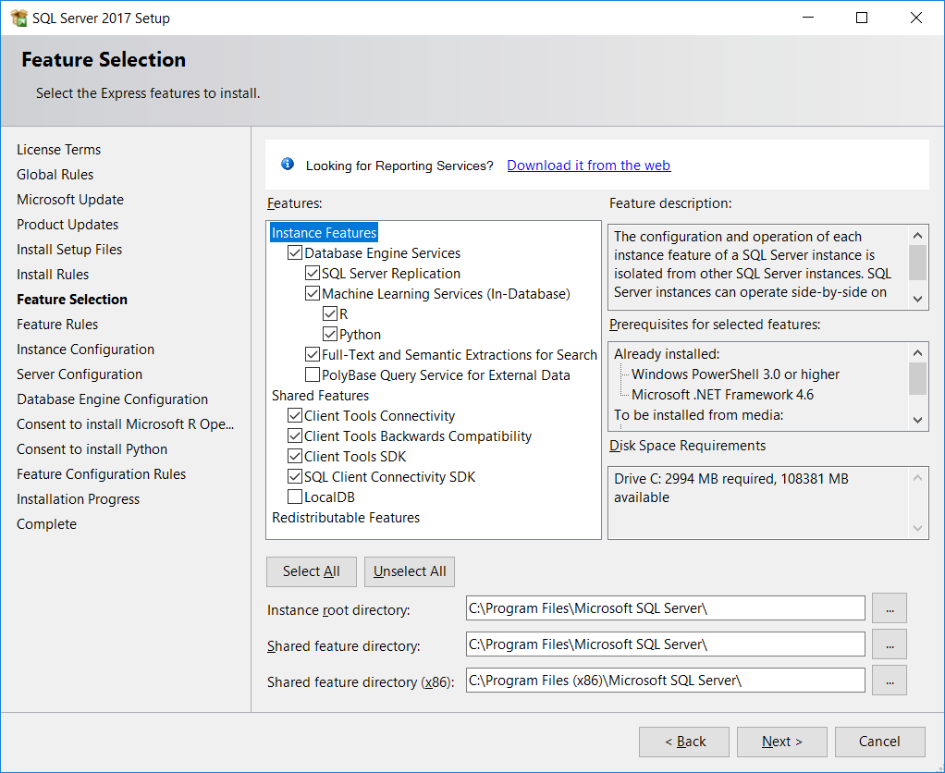

***Instance Configuration***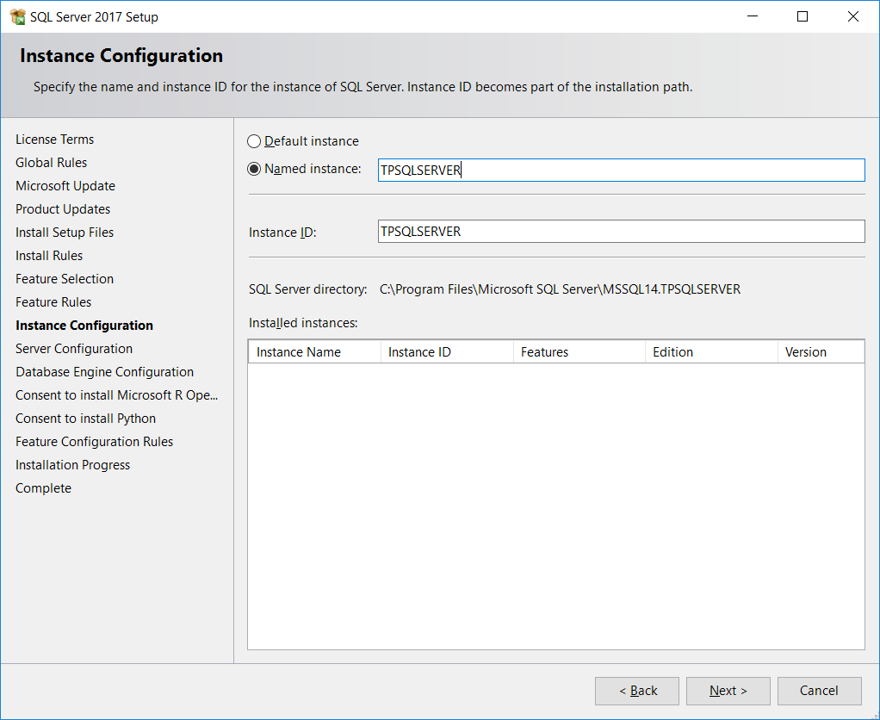

Named Instance: TPSQLSERVER

Instance ID: TPSQLSERVER

## Server Configuration

***Service Accounts***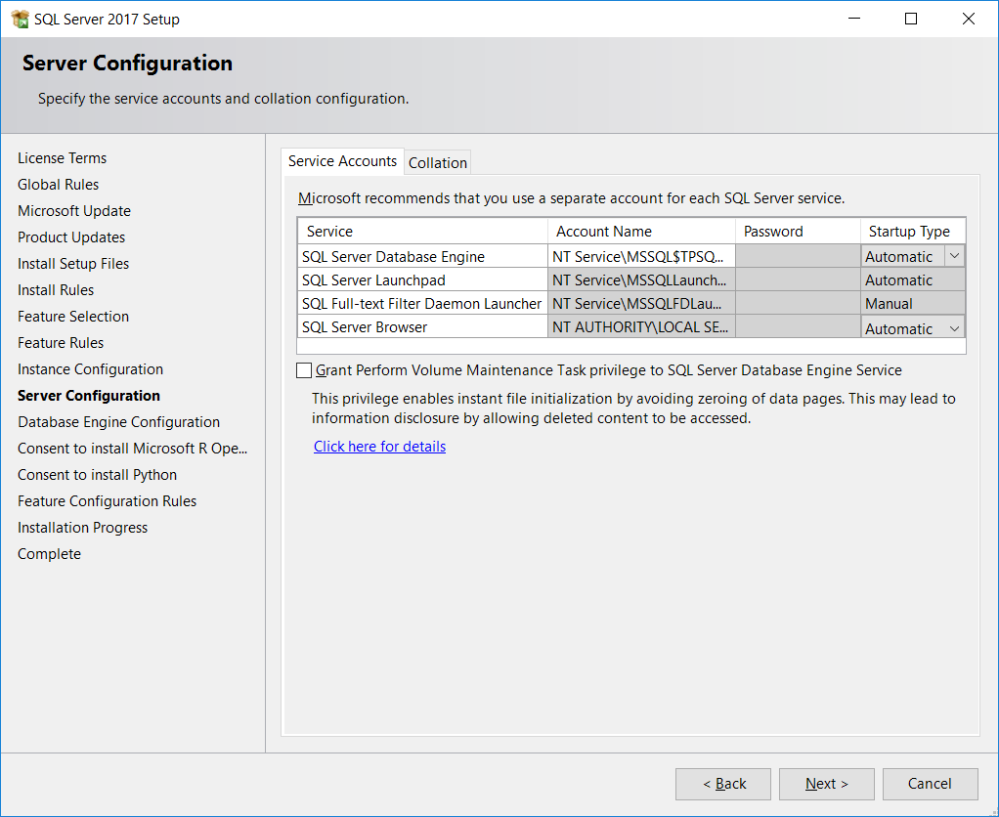

***Collation***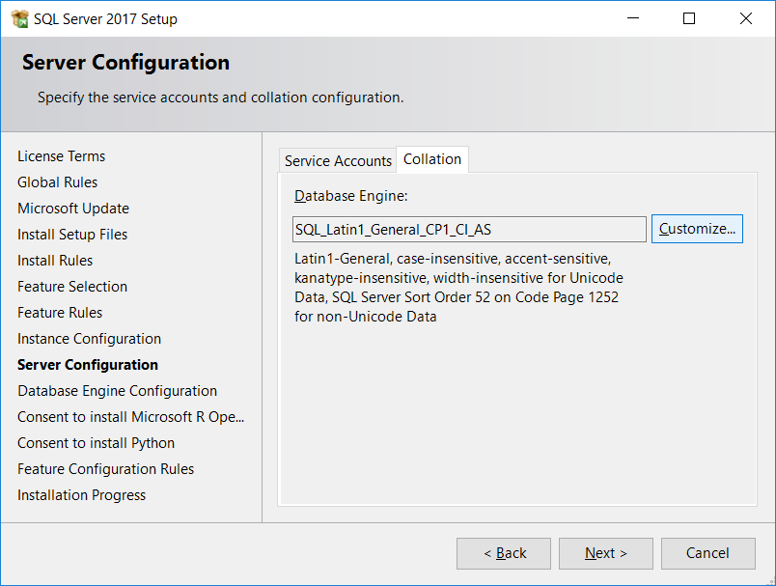

***Customize***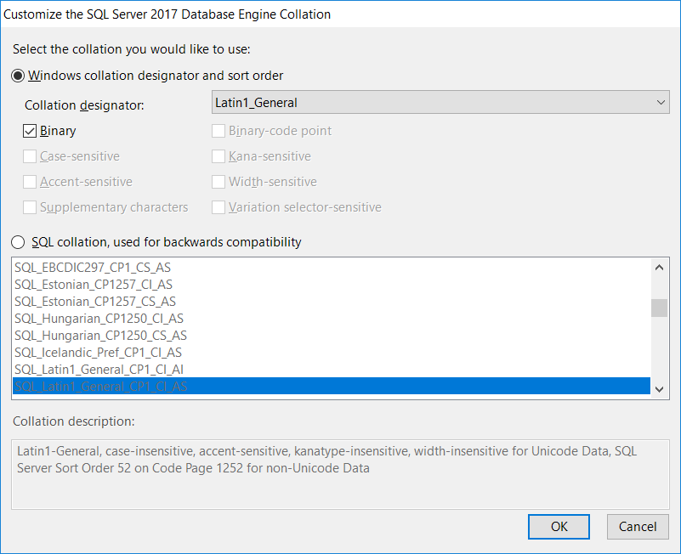

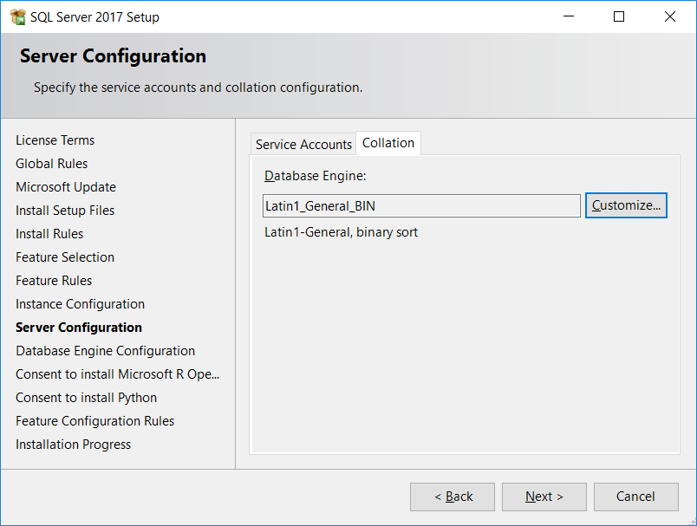

***Database Engine Configuration***

***Server Configuration***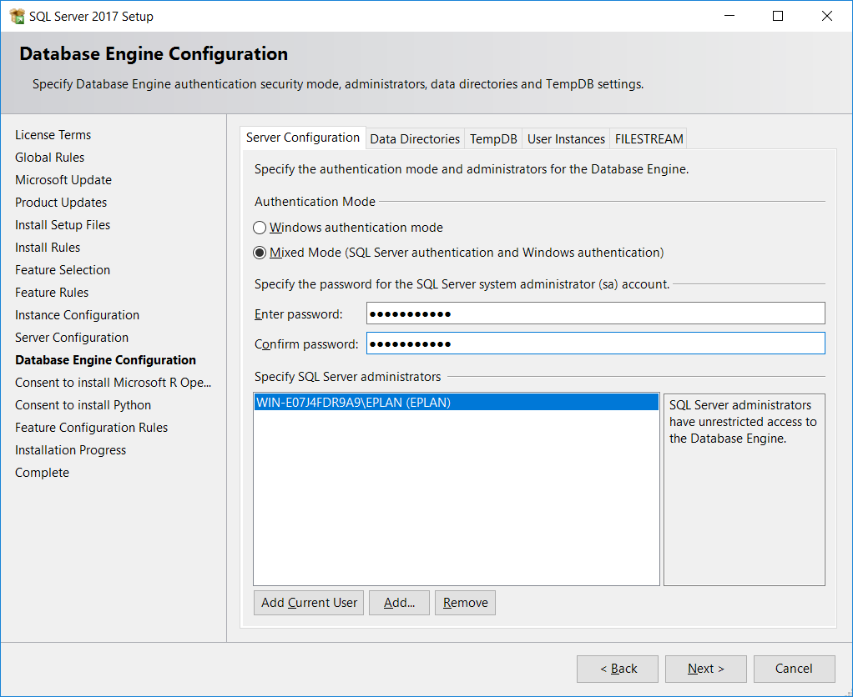

Passwort SQL Server system administrator (sa) account: tpsqlserver17!

Next/accept for the next screens

Complete

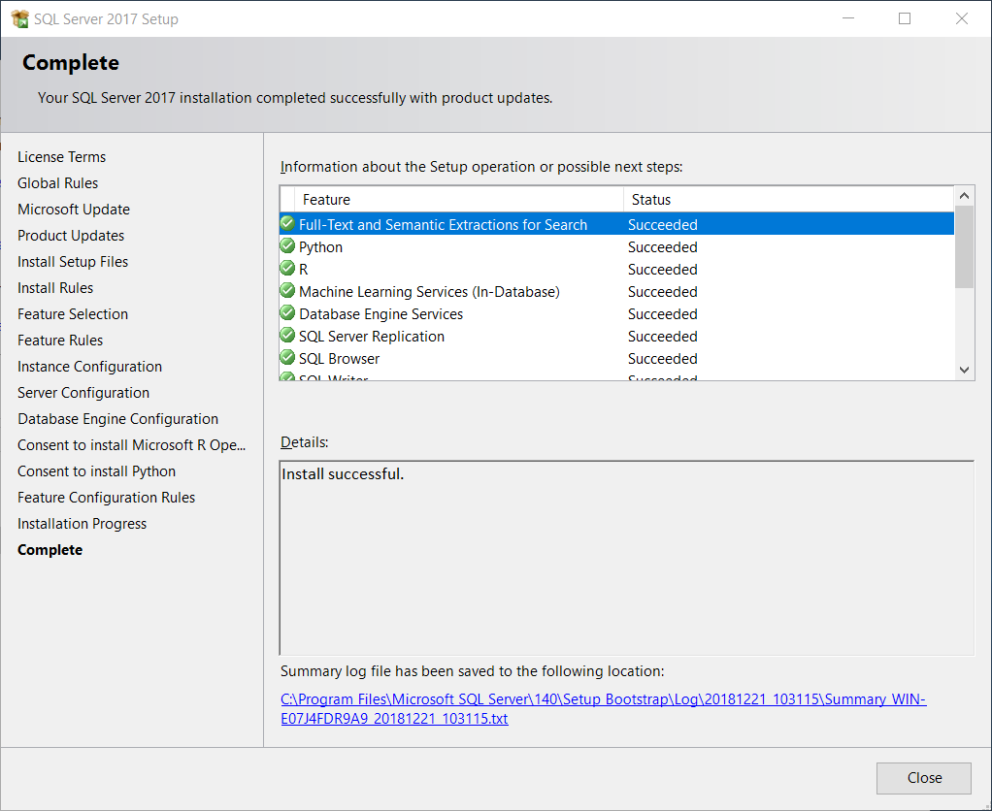

# Installation SQL Server Management Studion

*Run file as administrator*

"C:\Inst\SSMS-Setup-ENU.exe"

Install 🡪 Close

## Activate database protocols

Under certain conditions the configuration of MS-SQL-database protocols for TCP/IP and Named Pipes are not activated:

*🡪 SQL Server 2017 Configuration Manager 🡪 SQL Server Network Configuration 🡪Protocols for* „TPSQLSERVER“ 🡪 Named Pipes and TCP/IP enable

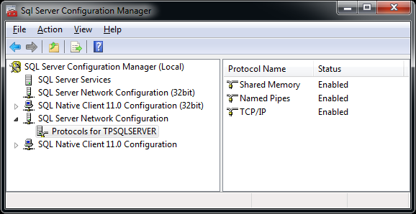

Under SQL server services restart „SQL Server (TPSQLSERVER)“ service!

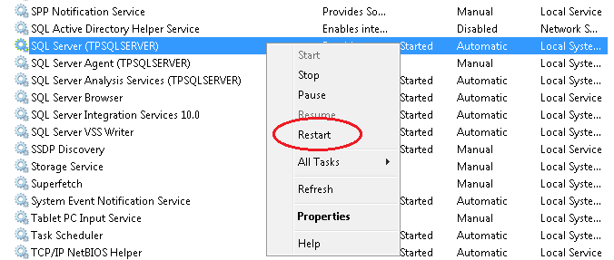

Installation JAVA

Installation JDK 1.8.0\_191 (64bit)

Java must be installed before installing the Teamcenter server.

*Run file as administrator*

jdk-8u191-windows-x64.exe

Installation path:

C:\Program Files\Java\jre1.8.0\_191\

C:\Program Files\Java\jre1.8.0\_191\

Set preconditions for PLM license server

For the installation of Teamcenter availability and access to a license from Siemens is required. Otherwise the installation process fails.

A Siemens PLM license server is already installed.

[28000@AzureLicense](mailto:28000@172.19.18.4) (IP: 172.19.18.4)

Modify hosts file

Edit

C:\Windows\System32\drivers\etc\hosts

Add following line at the end of the file  
172.19.18.4 AzureLicense  
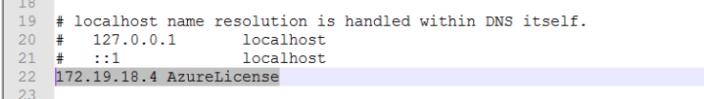

Installation Teamcenter

Create a Teamcenter database inside MS-SQL

The database must be created for Teamcenter before installing the Teamcenter server.

Edit script create database for MS-SQL database

Copy

**C:\Inst\Tc13.0.0.0\_wntx64\tc\db\_scripts\mssql\create\_database.sql.template**

To

**C:\Inst\Tc13.0.0.0\_wntx64\tc\db\_scripts\mssql\create\_database.sql**

In generation script **C:\Inst\Tc13.0.0.0\_wntx64\tc\db\_scripts\mssql\create\_database.sql** following changes should be done:

***Replace name of database***

OLD: @DB\_NAME@

NEW: TCDB

***Replace path for database file***

OLD: @DATA\_PATH@

NEW: C:\Program Files\Microsoft SQL Server\MSSQL14.TPSQLSERVER\MSSQL\DATA

***Replace User name***

OLD: @USER\_NAME@

NEW: infodba

***Replace infodba password***

OLD: @PASSWORD@

NEW: infodba

***Replace Collation***

OLD: @COLLATION@

NEW: Latin1\_General\_BIN

***Replace Language***

OLD: @LANGUAGE@

NEW: us\_english

***Add size database file***

OLD: …\TCDB\_Data.MDF’ , FILEGROWTH…

NEW: …\TCDB\_Data.MDF' , SIZE = 5 , FILEGROWTH…

Run database creation script

*Start 🡪 All Programs 🡪 Microsoft SQL Server Tools 17 🡪 Microsoft SQL Server Management Studio 17*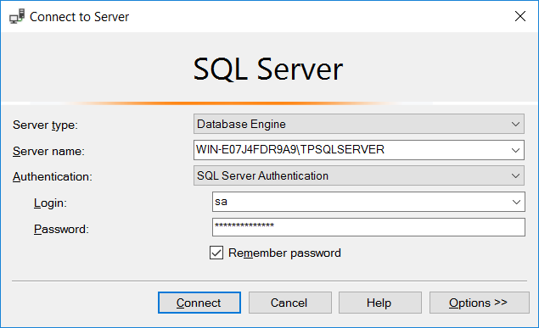

Server name: WIN-E07J4FDR9A9\TPSQLSERVER

Login: sa

Password: tpsqlserver17!

*File 🡪 Open 🡪 File*

**C:\Inst\Tc13.0.0.0\_wntx64\tc\db\_scripts\mssql\create\_database.sql** *🡪 Open*

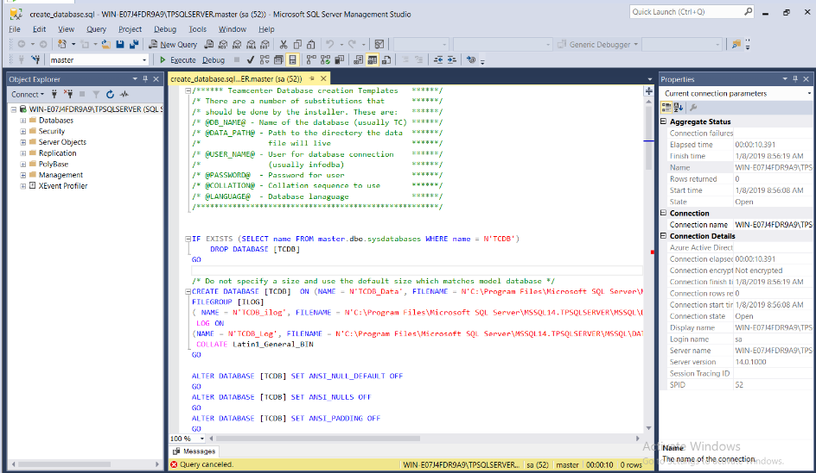

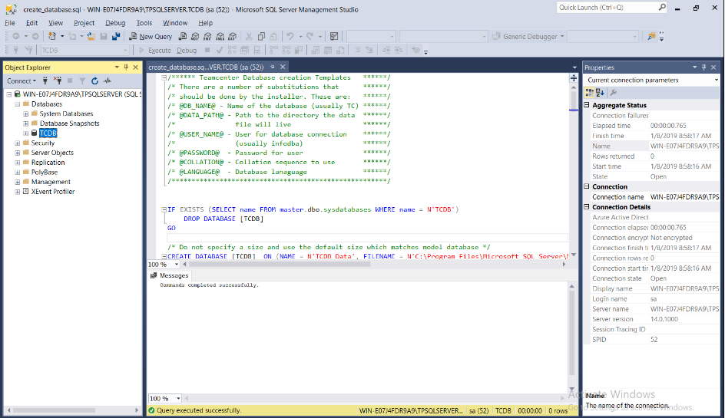

*Exit Microsoft SQL Server Management Studio*

Installation Teamcenter server incl. 2-tier client

*Run command window as administrator*

*Execute*

C:\Inst\Tc13.0.0.0\_wntx64\tem.bat -jre "C:\Program Files\Java\jre1.8.0\_191"

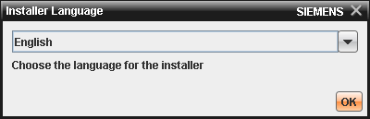

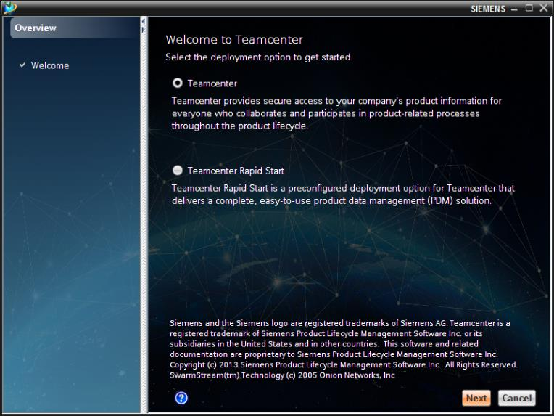

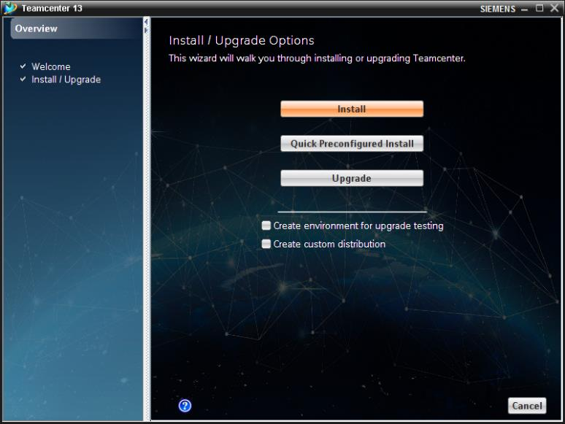

Meda Locations

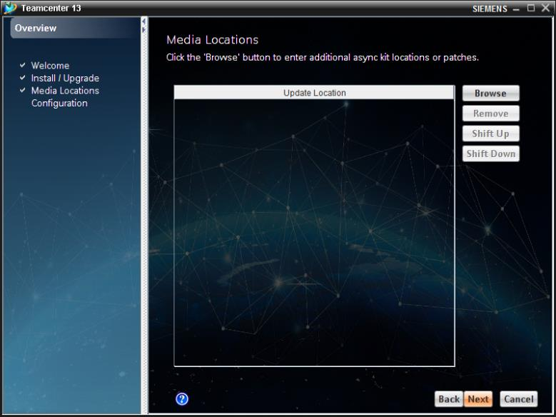

***Configuration***

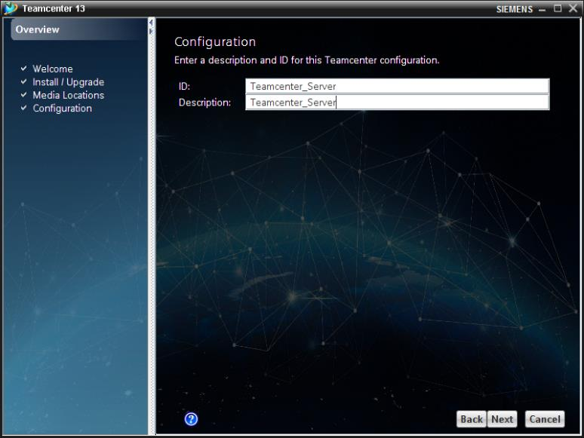

ID: Teamcenter\_Server

Description: Teamcenter\_Server

***Solutions***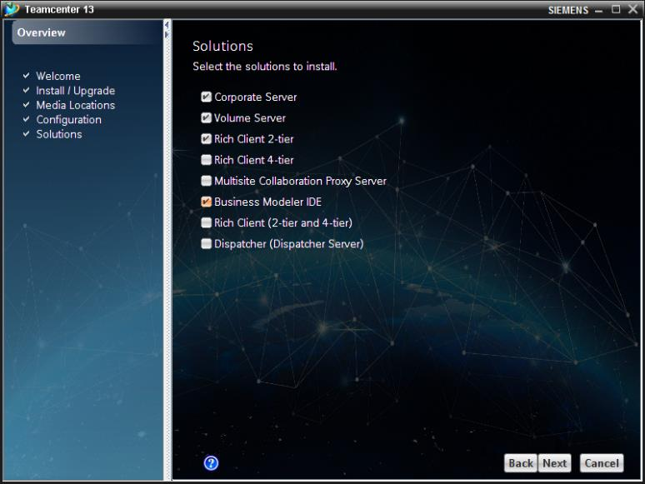

***Features***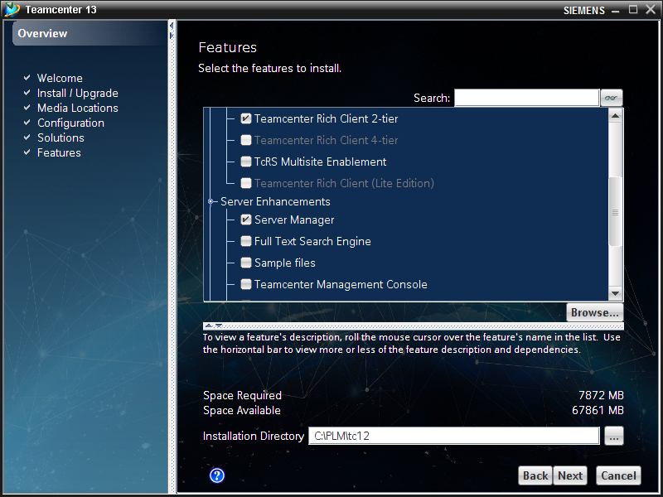

Installation Directory: C:\PLM\tc13

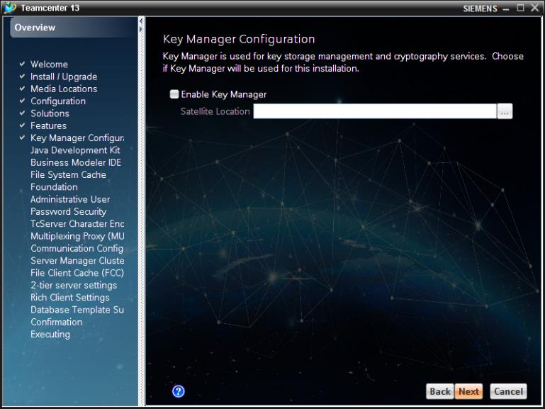

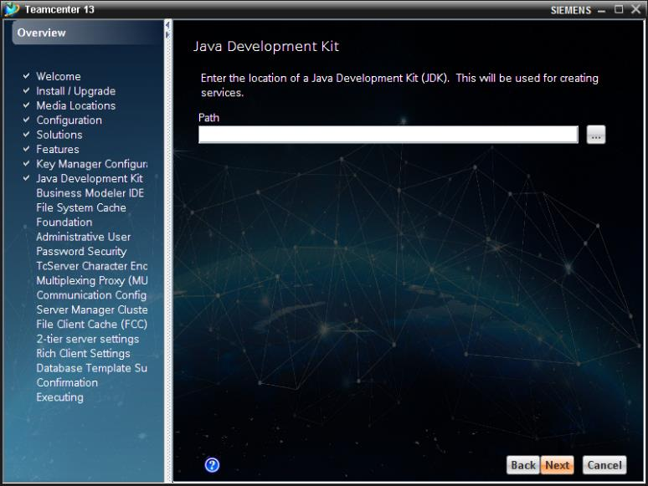

***Business Modeler IDE Client***

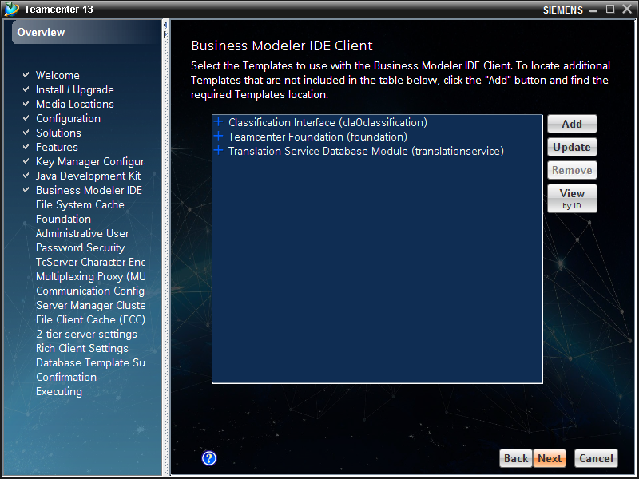

***File System Cache Service (FSC)***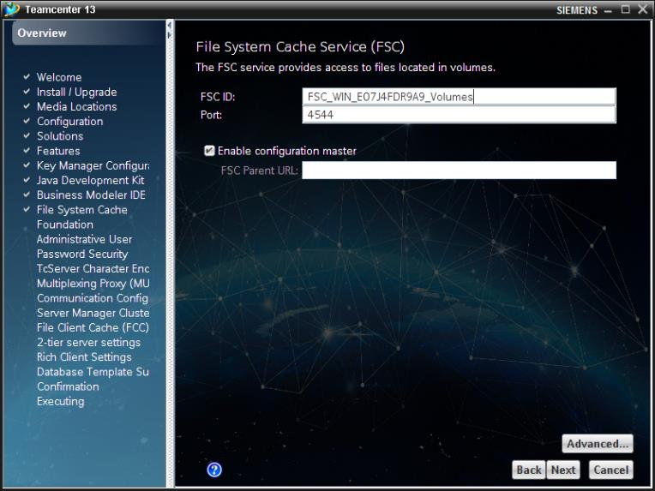

FSC ID: FSC\_WIN\_E07J4FDR9A9\_Volumes

Port: 4544

***Operating System User***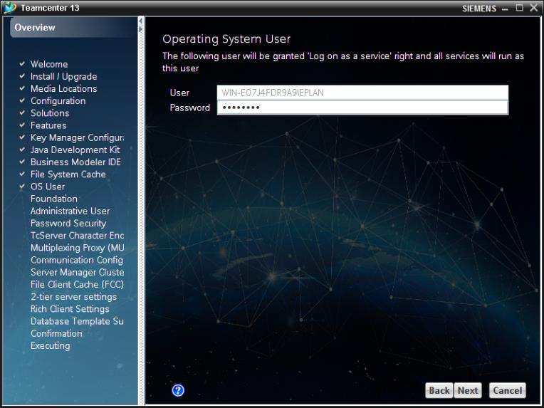

User: WIN-E07J4FDR9A9\EPLAN

Password: Hallo123

***Foundation***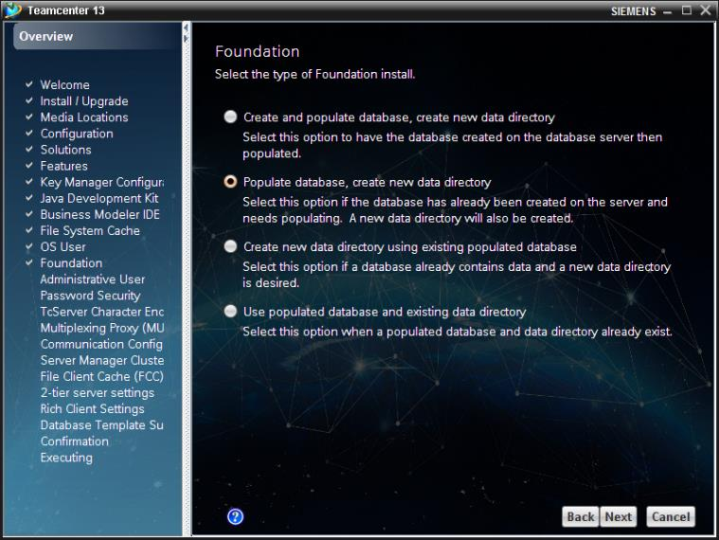

***Foundation Database - TC\_DATA***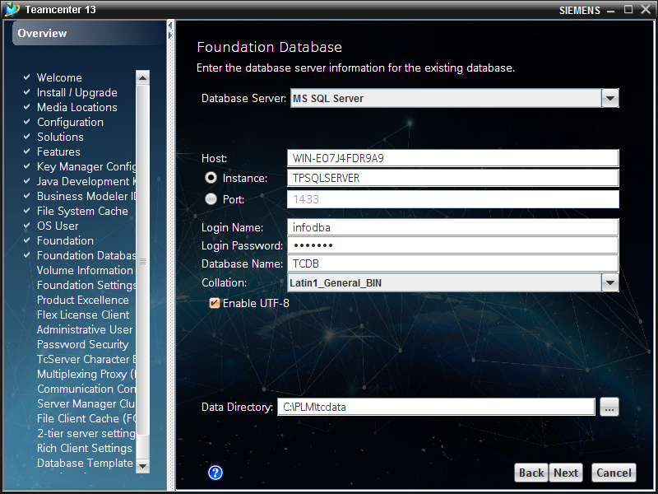

Host: WIN-E07J4FDR9A9

Instance: TPSQLSERVER

Login Name: infodba

Login Password: infodba

Database Name: TCDB

UTF-8: Enable

Data Directory: C:\PLM\tcdata

***Volume Information***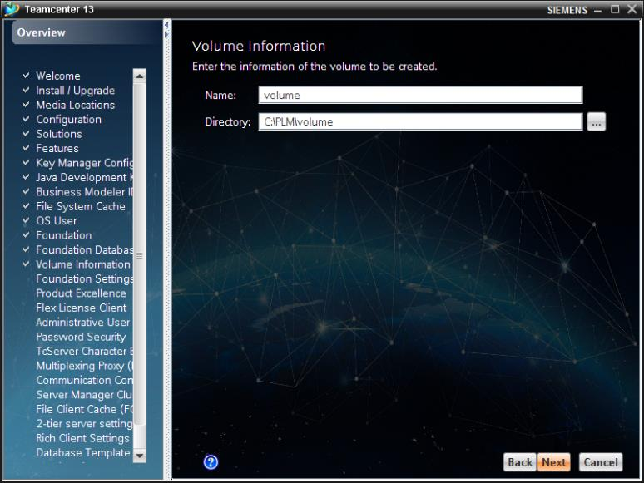

Name: volume

Directory: C:\PLM\volume

***Foundation Settings – Transientvolume***

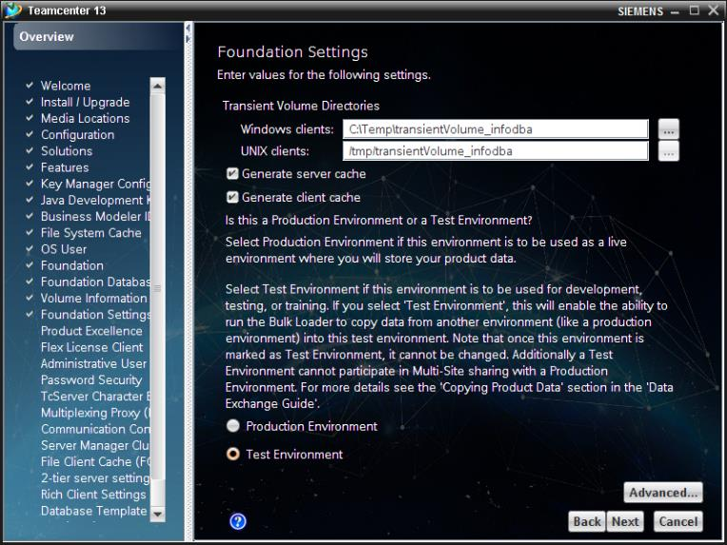

Transient Volume Directory: C:\Temp\transientVolume\_infodba

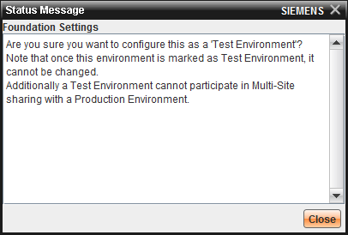

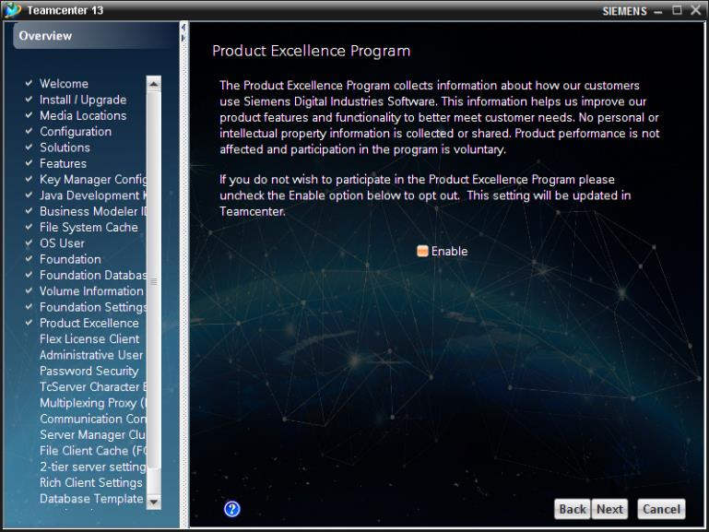

***Flex License Client***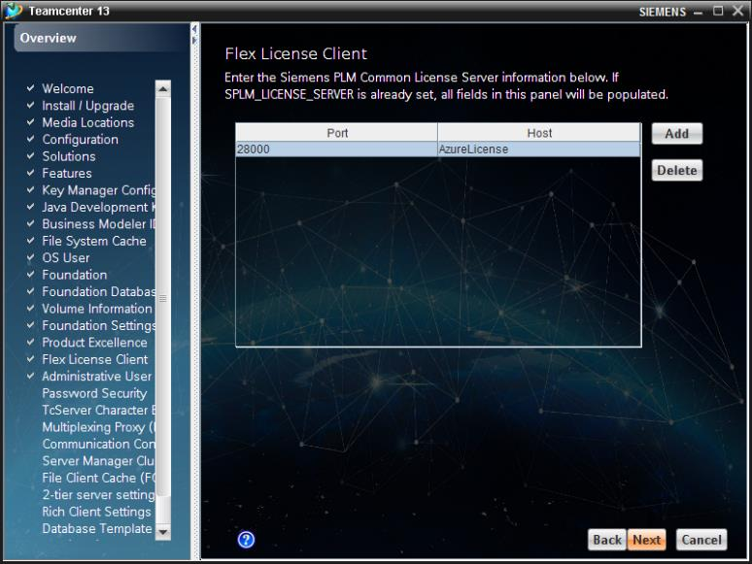

Port: 28000

Host: AzureLicense

***Teamcenter Administrative User***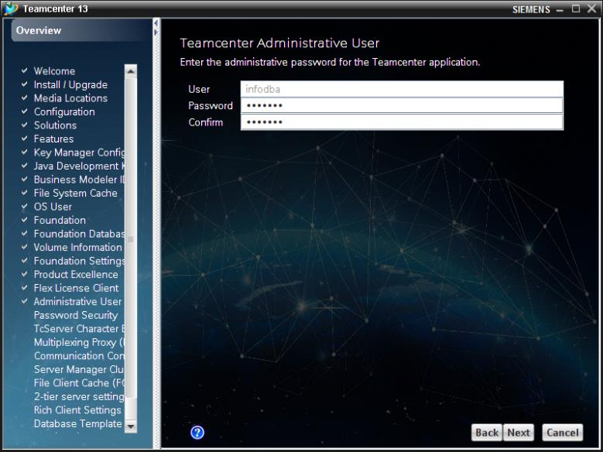

User: infodba

Password: infodba

***Password Security***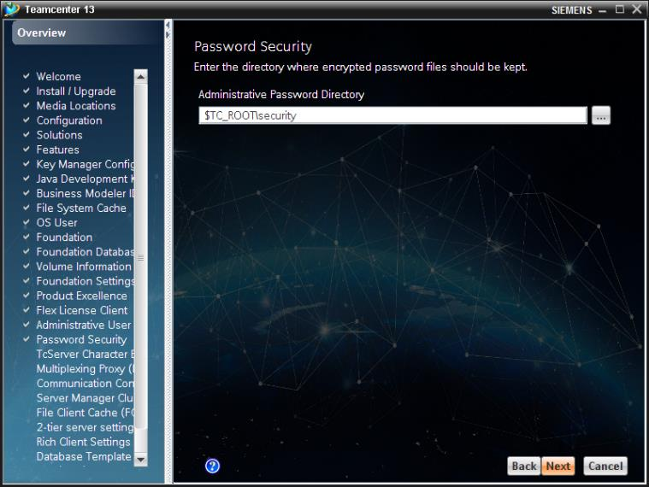

***TcServer Character Encoding Settings***

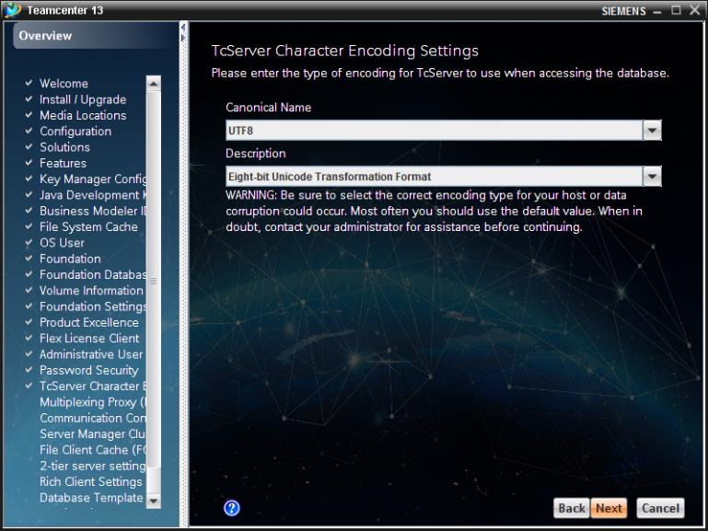

***Multiplexing Proxy (MUX)***

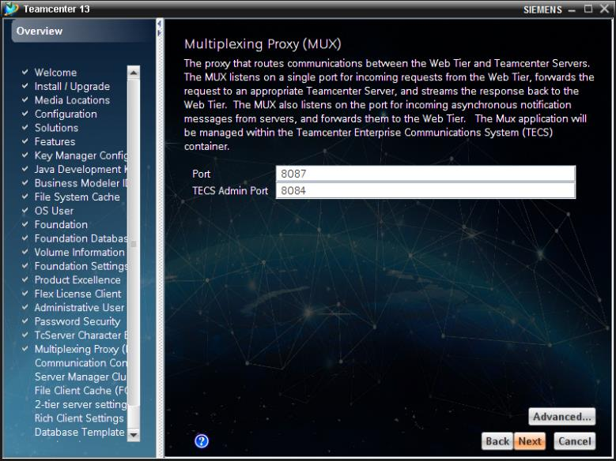

***Communication Configuration***

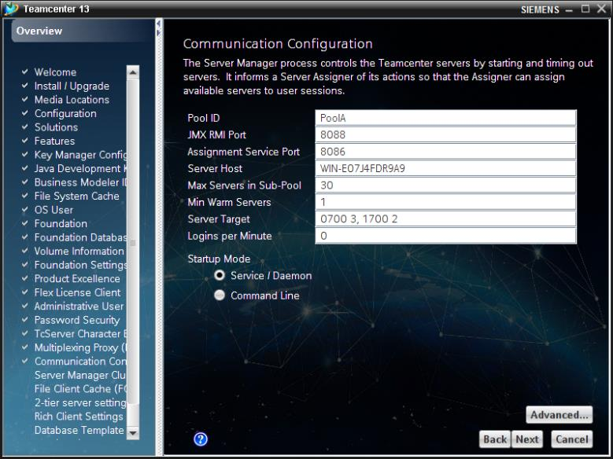

***Management Console LDAP Configurations***

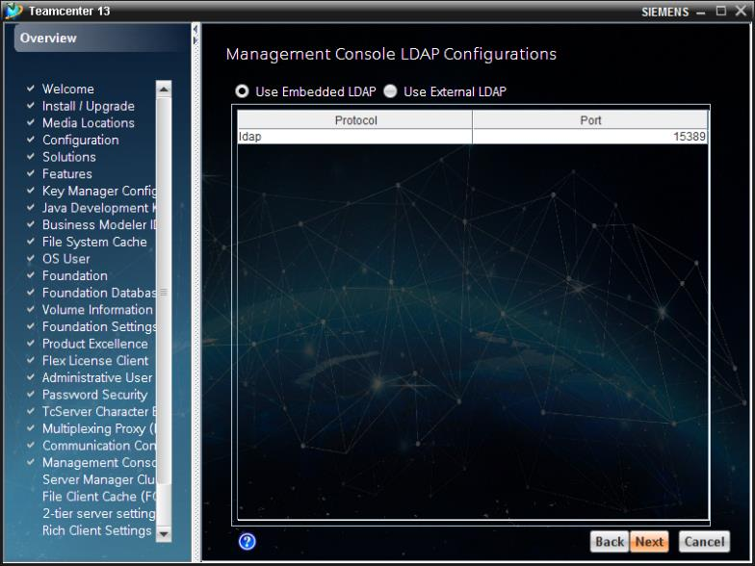

***Server Manager Cluster Configuration***

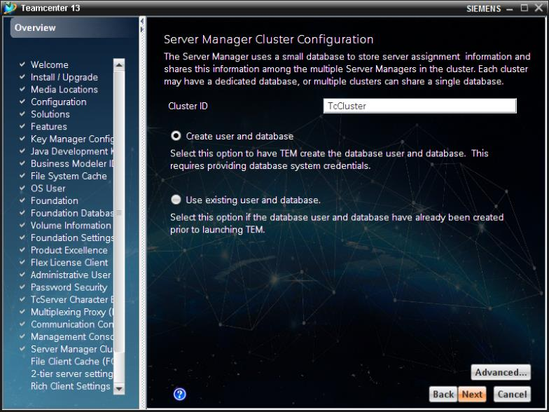

***Server Manager Database***

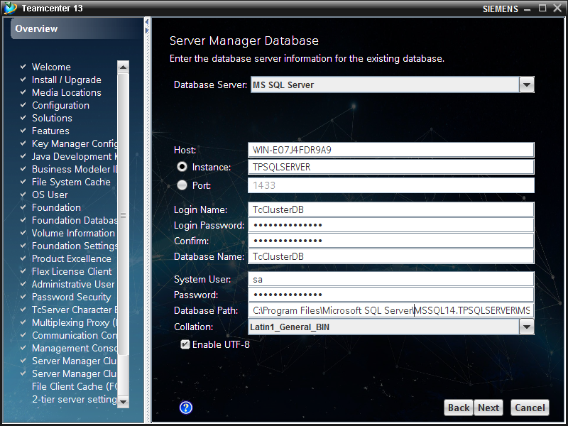

Database Server: MS SQL Server

Host: WIN-E07J4FDR9A9

Instance: TPSQLSERVER

Login Name: TcClusterDB

Login Password: tpsqlserver17!

Database Name: TcClusterDB

System User: sa

Password: TcClusterDB

Database path: C:\Program Files\Microsoft SQL Server\MSSQL14.TPSQLSERVER\MSSQL\DATA\

Collation: Latin1\_General\_BIN

Enable UTF-8 true

***File Client Cache (FCC)***

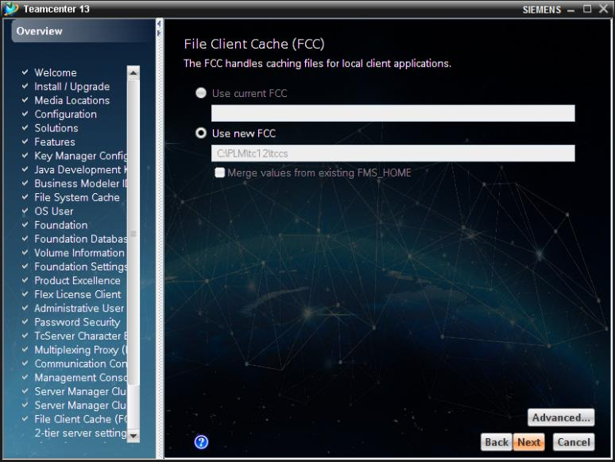

FCC Path: C:\PLM\tc101\tccs

***FCC Parents***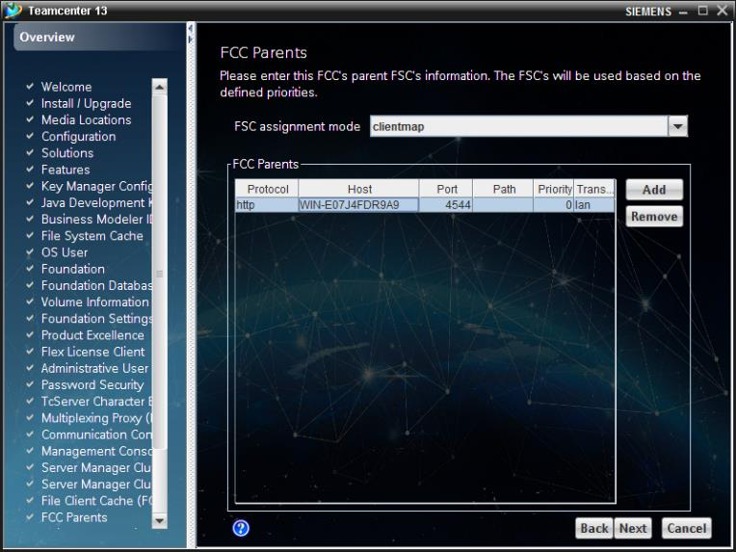

Host: WIN-E07J4FDR9A9

***2-tier server settings***

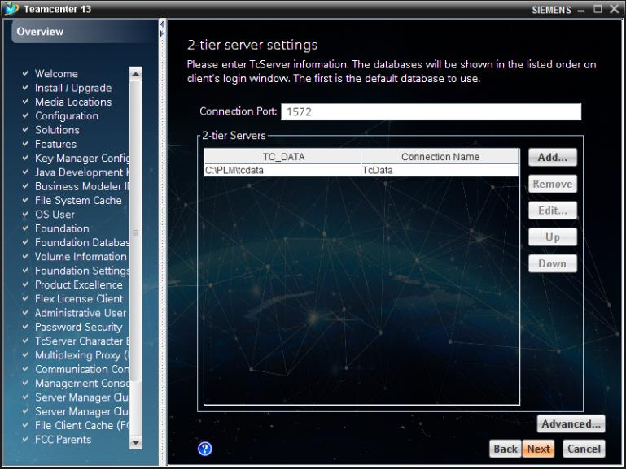

Connection Port: 1572

TC\_DATA: C:\PLM\tcdata

Connection Name: TcData

***Rich Client Settings***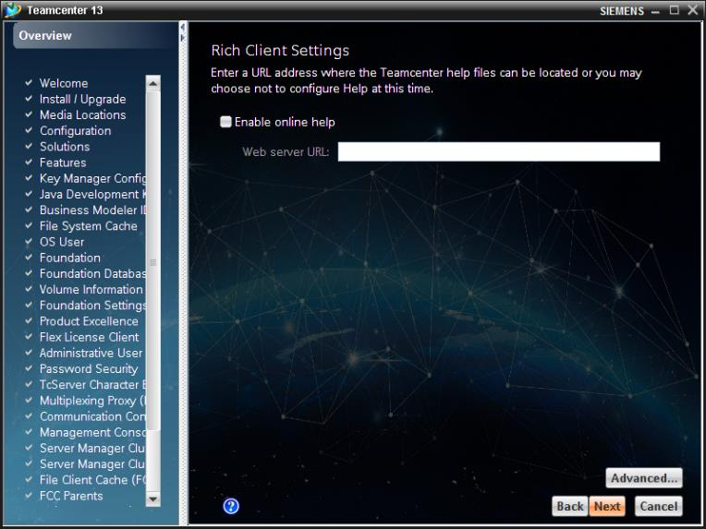

***Database Template Summary***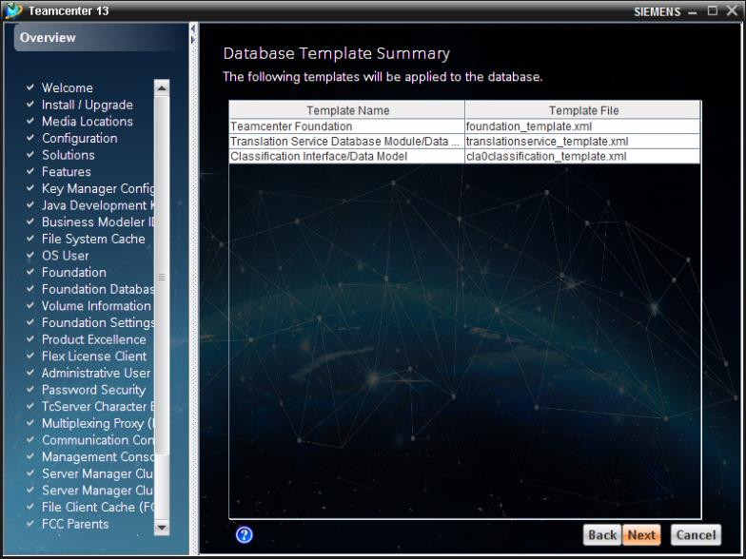

***Confirmation***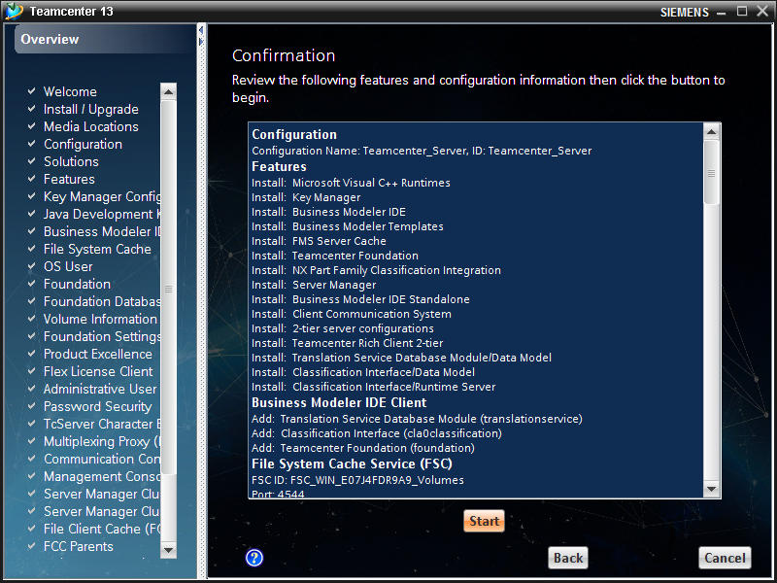

***Installation***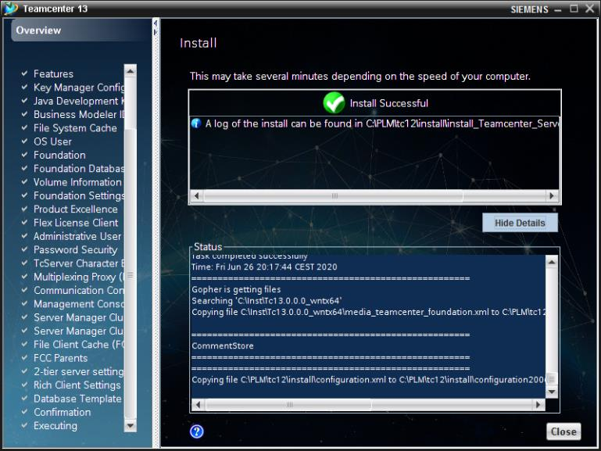

Installation 4-Tier Client

*Run command window as administrator*

*Execute*

C:\inst\Tc13.0.0.0\_wntx64\tem.bat -jre "C:\Program Files\Java\jre1.8.0\_191"



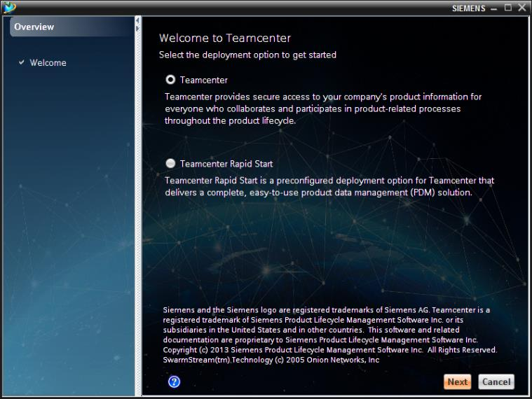





***Configuration***

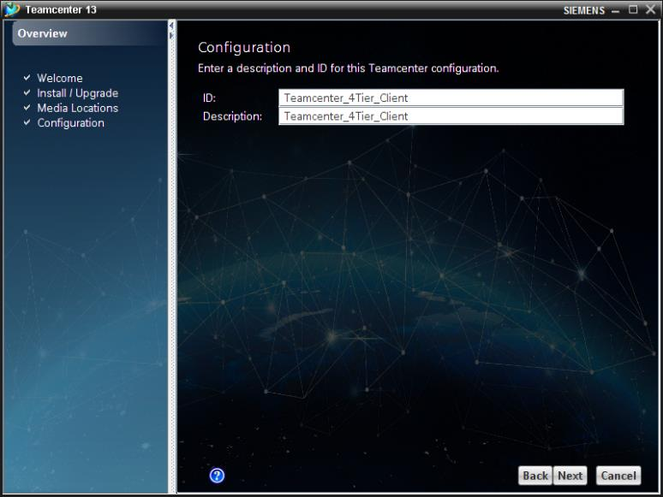

ID: Teamcenter\_4Tier\_Client

Description: Teamcenter\_4Tier\_Client

***Solutions***

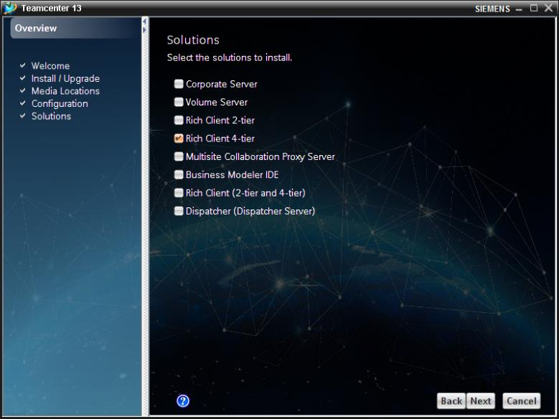

***Features***

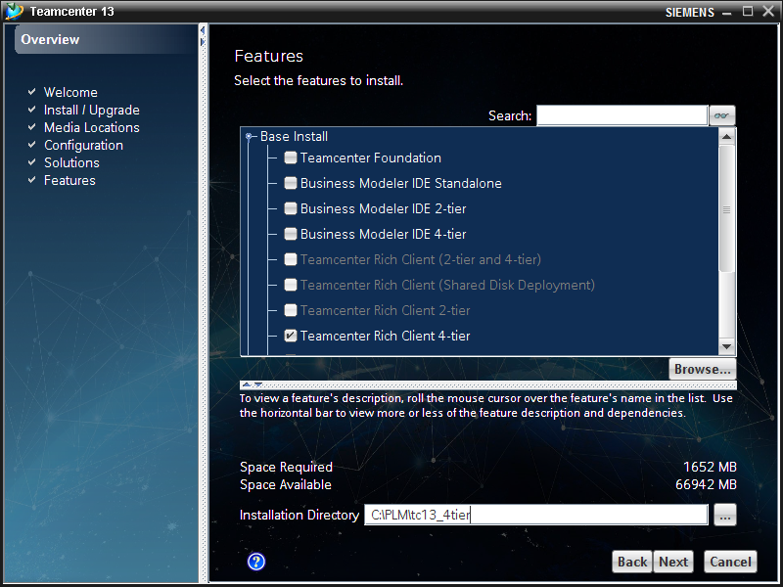

Installation Directory: C:\PLM\tc13\_4tier

***File Client Cache (FCC)***

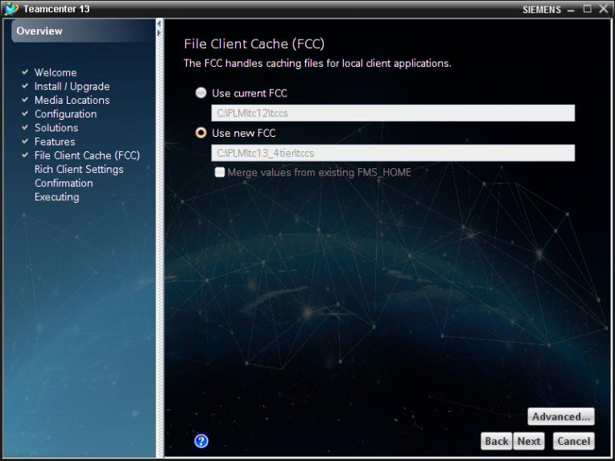   
FCC Path: C:\PLM\tc13\_4tier\tccs

***FCC Parents***

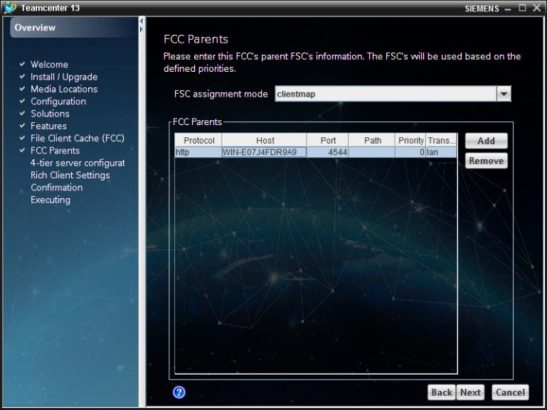  
Host: WIN-E07J4FDR9A9

***4-tier server configurations***

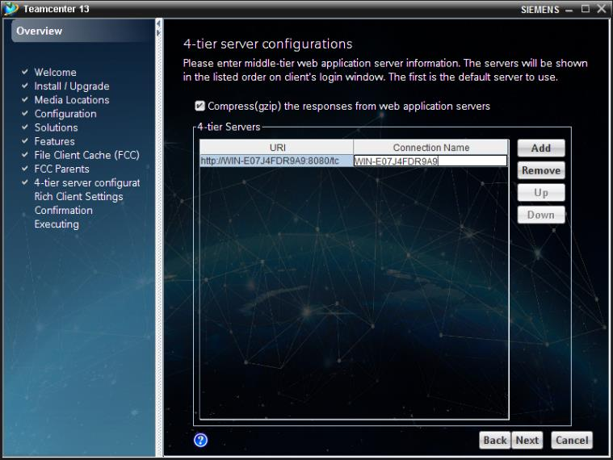  
URL: http://WIN-E07J4FDR9A9:8080/tc

Connection Name: WIN-E07J4FDR9A9

***Rich Client Settings***

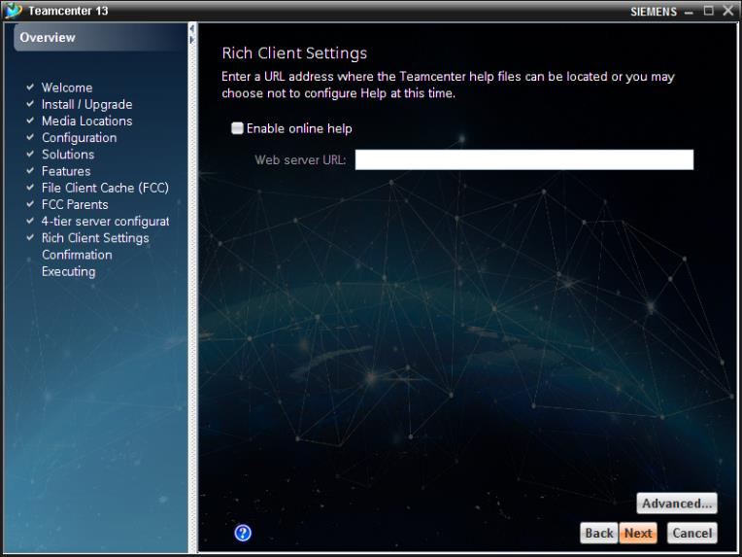

***Confirmation***

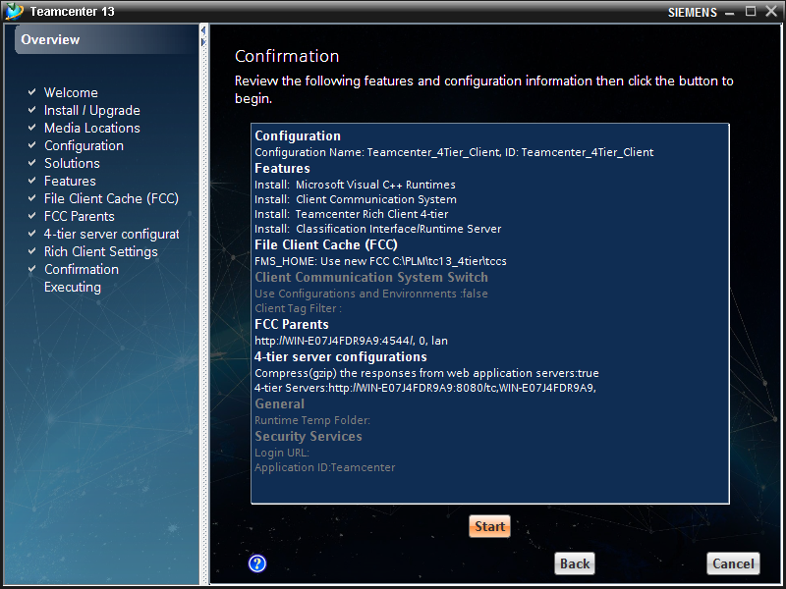   
***Installation***

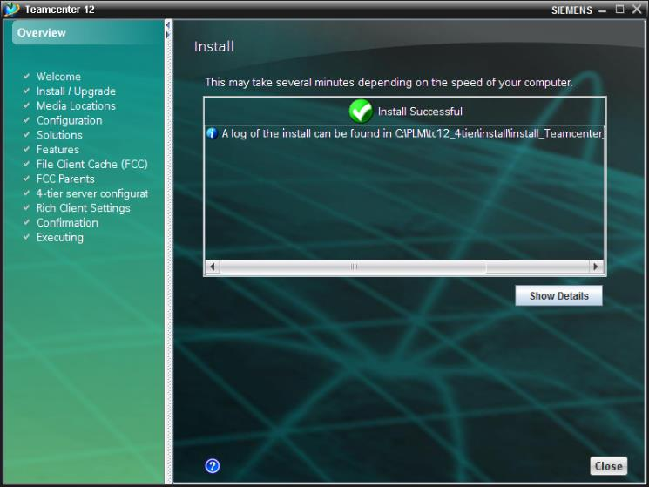

Installation Thin-Client

*Create directory*

C:\PLM\web\_tier

*Execute*

C:\inst\Tc12.0.0.0\_wntx64\Web\_tier\INSTALL\_TCWEB.EXE

*Extract to*

C:\PLM\web\_tier

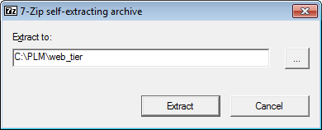

Copy the ICDs of Tc13

*Open command window as administrator*

*Execute*

C:\PLM\web\_tier\insweb.bat

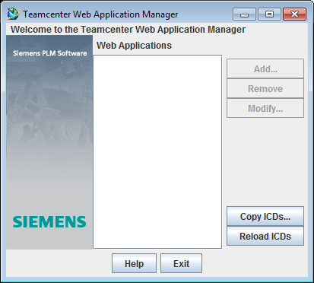  
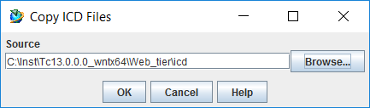

Source: C:\inst\Tc13.0.0.0\_wntx64\Web\_tier\icd

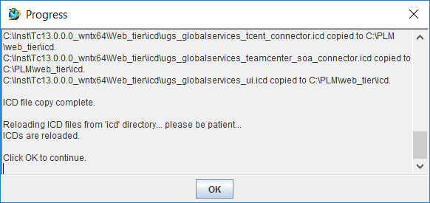

Add the web\_tier

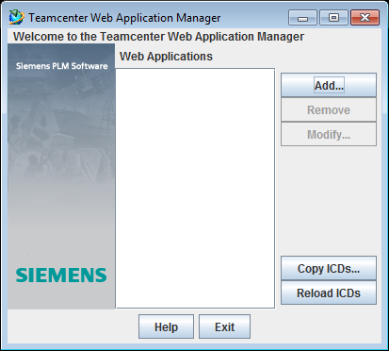

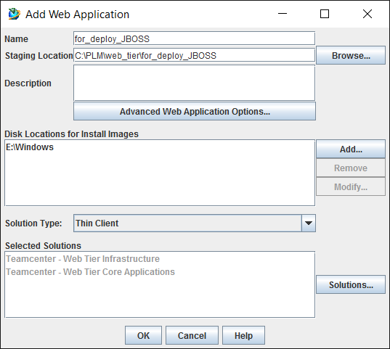

Name: for\_deploy\_JBOSS

Staging Location: C:\PLM\Web\_tier\for\_deploy\_JBOSS

Disk Locations for Install Images:

Remove E:\Windows

Add Tc13.0:

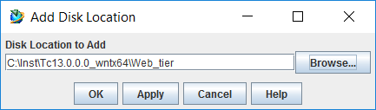

-C:\inst\Tc13.0.0.0\_wntx64\Web\_tier

Solutions

Add Solutions

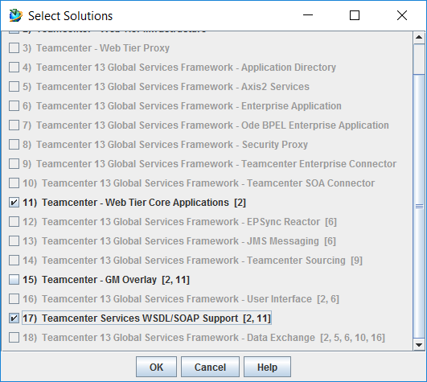

Modify Required Context Parameters

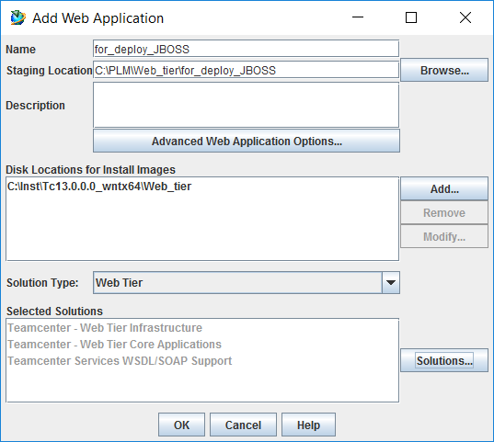

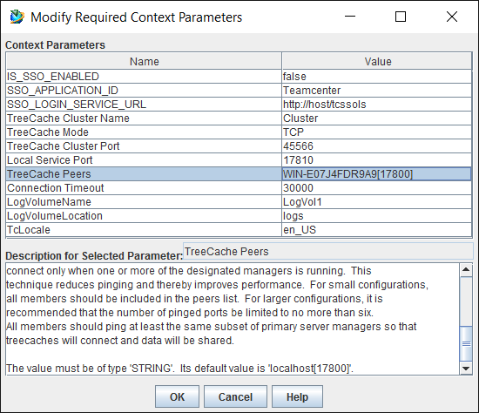

Server\_Manager\_URLs: http://WIN-E07J4FDR9A9:8086/PoolA

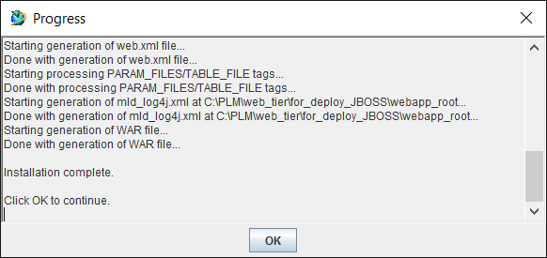

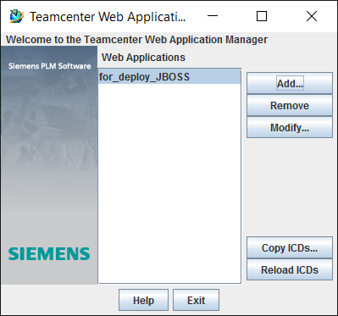

Installation and configuration Apache Web Application Server

Installation Tomcats

*Extract*

C:\inst\apache-tomcat-8.5.37-windows-x64.zip

*Copy content to*

C:\PLM\apache-tomcat-8.5.37

Deploy of web\_tiers

*Copy*

C:\PLM\web\_tier\for\_deploy\_JBOSS\deployment\tc.war

*to*

C:\PLM\apache-tomcat-8.5.37\webapps

Set system variables

* JAVA\_HOME = C:\Program Files\Java\jdk1.8.0\_191 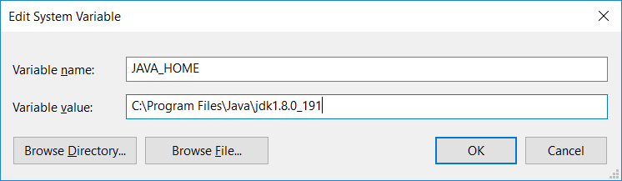
* JRE64\_HOME = C:\Program Files\Java\jre1.8.0\_191  
  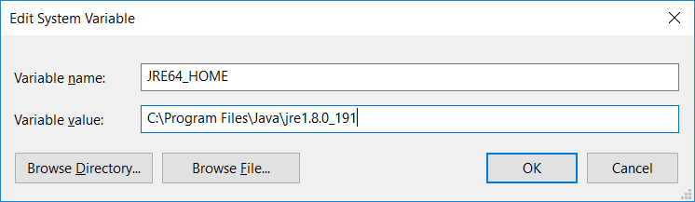
* CATALINA\_HOME = C:\PLM\apache-tomcat-8.5.37  
  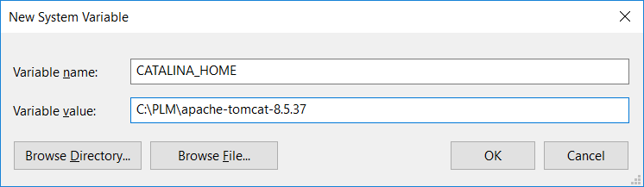
* CATALINA\_BASE = C:\PLM\apache-tomcat-8.5.37  
  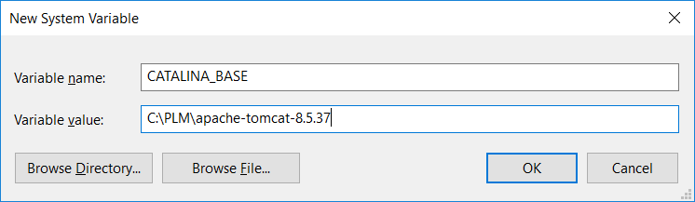

Setup

*Run CMD as administrator*

*Execute*

*C:\PLM\apache-tomcat-8.5.37\bin\service.bat install*

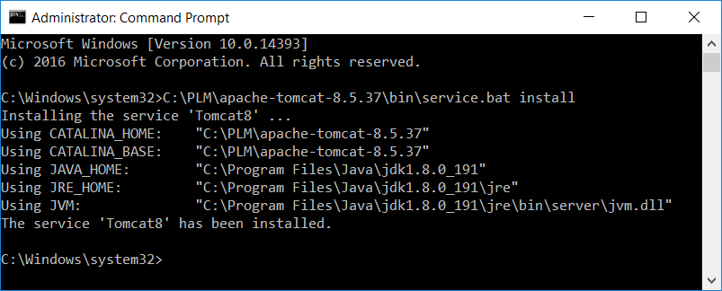

Automatic Service

Set service Apache Tomcat 8.5 Tomcat8 to Automatic

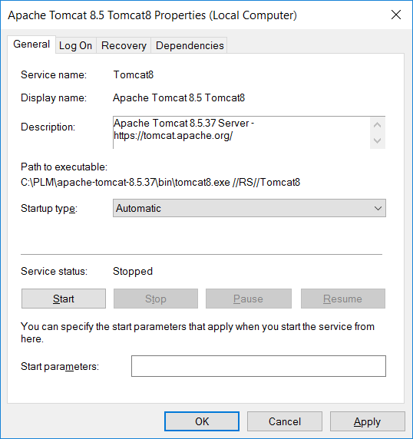

|  |  |
| --- | --- |
| ePLAN_RGB_W | EPLAN Software & Service GmbH & Co. KG  An der alten Ziegelei 2  40789 Monheim am Rhein · Germany  Telefon: +49 (0) 21 73 / 39 64-0  Telefax: +49 (0) 21 73 / 39 64-25  [Info@eplan.de](mailto:Info@eplan.de) · [www.eplan.de](http://www.eplan.de) |